

electronic Customs management system
User Guide

On

Declaration- aPPROVAL

Version: 1.0
Date: 05/09/2022

About Yang Khor Pvt Ltd

Yang Khor IT Solutions is a leading In-country Technology Solutions Provider providing solution in terms of hardware, software, support, and services as its complete package.
Yang Khor IT Solutions has been serving its purpose since 2005, it now has emerged to be an unprecedented leader as a Solution Integrator with a differentiated vertical approach to providing innovative solutions. Yang Khor uses its solution integration capabilities to integrate best-of-breed products through its key technology alliance partners to provide “End to End” solutions. Provide customized business solutions that help organizations accelerate revenue growth, increase market penetration, optimize operating costs and improve employee productivity, by embedding communication in their business processes.

Yang Khor IT Solutions has achieved to be the Gold Partner of HPE, Service One Partner of HPE, Microsoft Silver Partner and VMWARE Professional Partner and having this Partnership we are able to serve the best of solution to our clients. Yang Khor IT Solution initially focuses on providing the best solution in terms of hardware and software, to serve the purpose of making life better with the Advance Technology which the world is moving forward with.

DOCUMENT HISTORY
S.No | Date | Version. No | Description | Approved By
1 | 05/09/2022 | 1.0 | First Release

Contents
Chapter 1- About This Guide 4
Purpose and Audience 4
Document Conventions 4
Chapter 2- Getting Started 5
End-user experience of the self-service process 5
1. Logging In 5
1.1. Forgot/Reset password? 6
Chapter 3- Approve International Transit Declaration. 9
Declaration Approval 10
Approve Dispatch Challen 14
Release Order 15
Release Cargo 16
Get Out Dispatch Challan 18
Get In Dispatch Challan 20
Payment 22
Pending Payment 23
Valuation 25
Centralized Risk 26
Release Order 27
Release Cargo 28

Chapter 1- About This Guide
Welcome to the Trade Facilitation Baseline Customs Management System (eCMS) user guide for CFA USER! This user guide aims to enumerate the process and steps involved in using eCMS.
This user guide is divided into different topics and sub-topics. Each topic discusses and shows the steps of the modules that the eCMS.

Purpose and Audience
This user guide will help the user to get a quick reference on usage of the system.

Document Conventions
Refer to this section to familiarise yourself with the visual aids used throughout the user guide.
Navigation
To assist you with accessing screens, pages, or windows, refer to the following navigation format:
Click User Registration>>Users
Buttons, fields, and other system elements
All system elements are highlighted in Bold text.
Hyperlinks
All topics mentioned in the user guide’s content are hyperlinked. Click on the hyperlink to view the referenced topic.
Callouts
Callouts are presented differently from the original CONTENTS and highlight certain information.
There are two types of callouts: tips and warnings.

@ | A Tip provides useful information that helps you complete a task or procedure.

! | A Warning refers to information that may be critical to the system’s functionality and might affect data or system stability.

Chapter 2- Getting Started
Refer to this chapter to familiarize yourself with the eCMS System; how to log in, Approve Exemption, and log off from the system.

End-user experience of the self-service process

Logging In
To log in to the eCMS:
- Type in URL http://uat.ecms.gov.bt/ECMS/login/indexBhutan.jsp in your Internet browser to access the eCMS System.
- eCMS Front End landing page will display as below,

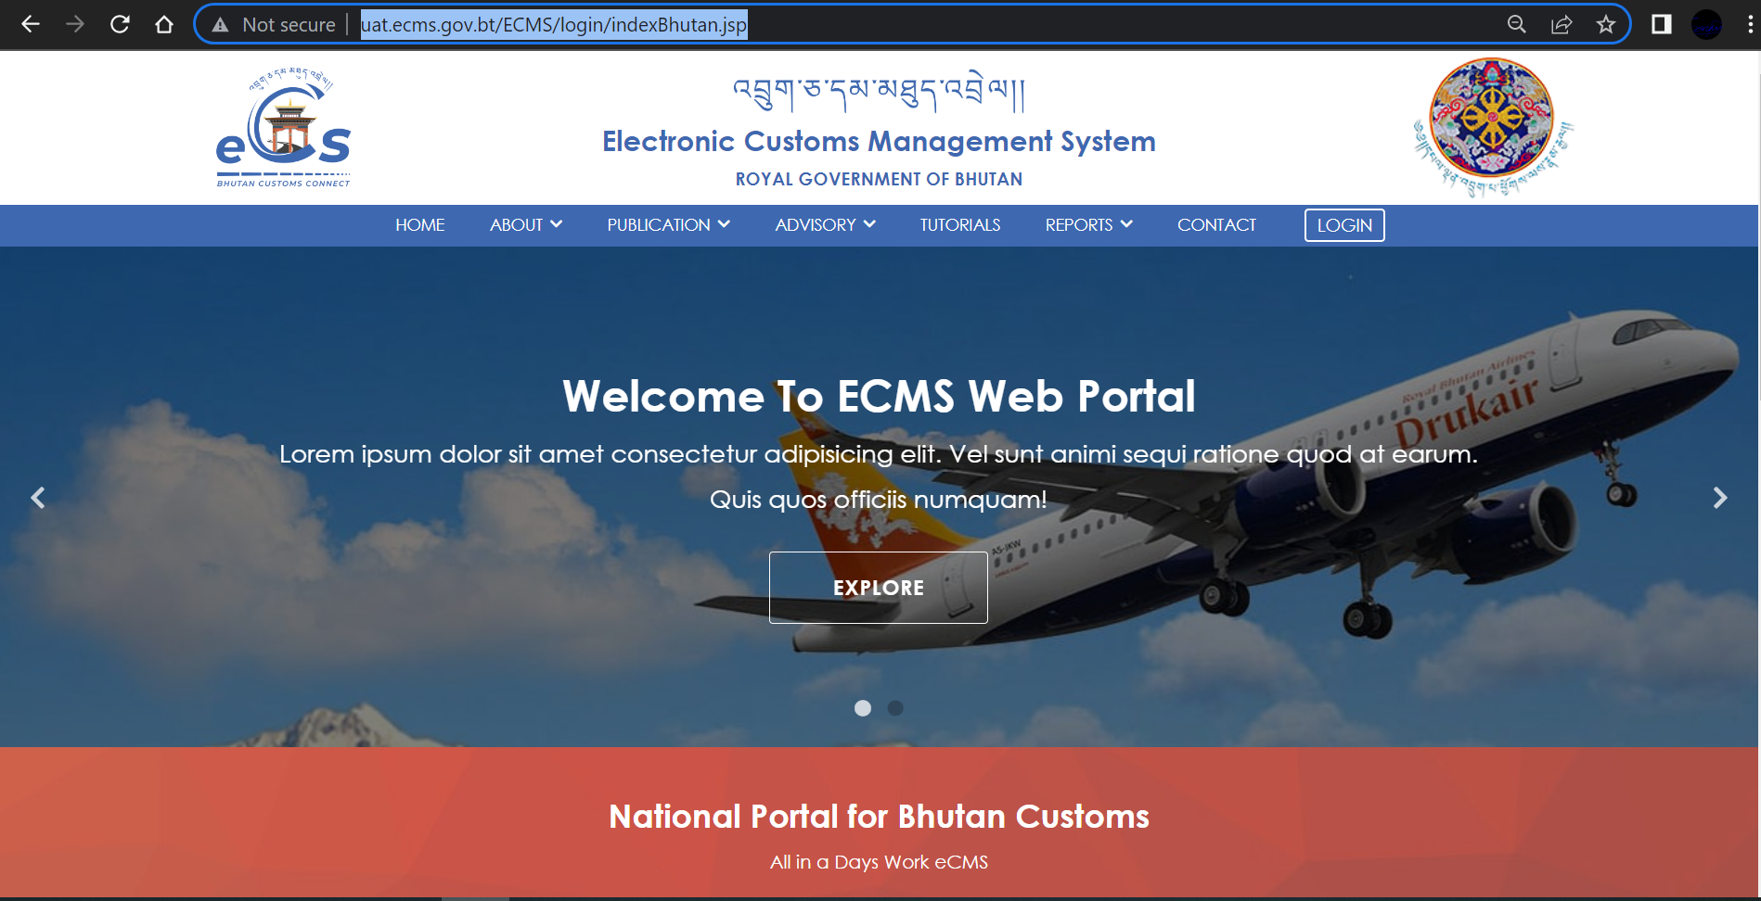

Fig.1. eCMS Landing page

- Click>>> LOGIN available on the top right corner of the landing page

  - Click >>LOGIN, the following login screen (Figure 2) is displayed

eCMS Login

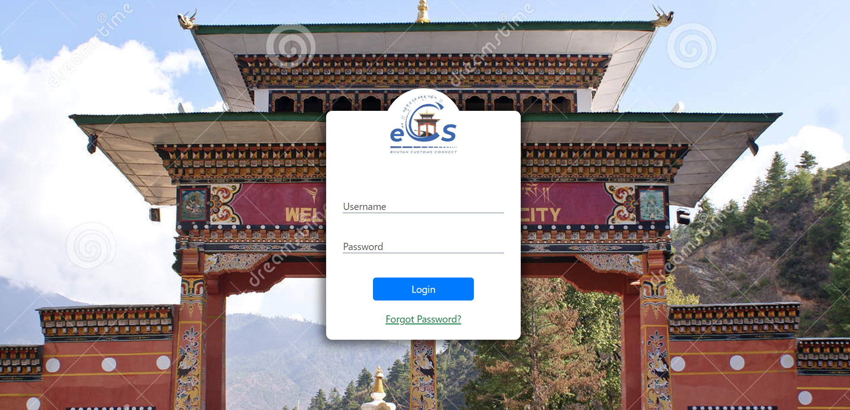
fig.2. eCMS login Page

  - Enter the USERNAME and the PASSWORD in the fields provided and Click button.

@ | In case you need to reset or forgot your password, On the login page, the user clicks the Forgot Password? link to start the process. The new password will be sent to your registered email.

Forgot/Reset password?
- If User Password is expired or forgot , Click >>“Forgot Password?”, “Forgot password Form” is displayed as shown in the figure 3 above.

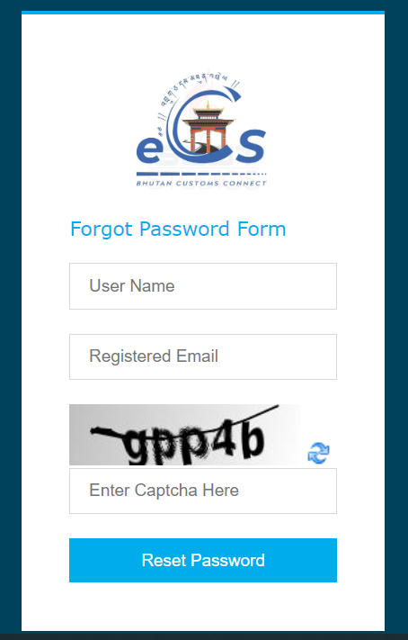
Fig.2. Forgot Password Form.
- Fill in the required details “User Name”, “Registered Email”, “Enter Captcha” and click on “Reset Password” Buttom. The subsequent screen is displayed;
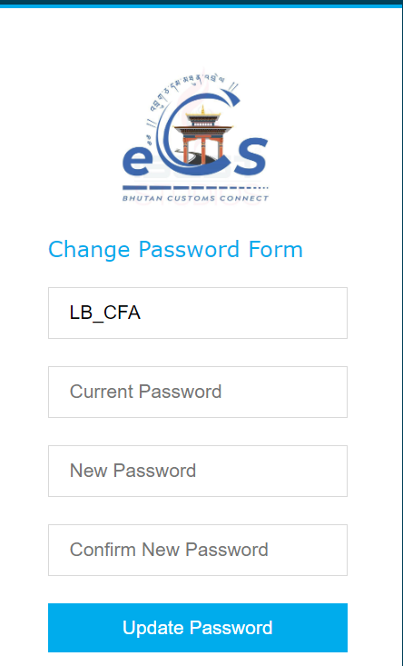
Fig.3. Update password

- Check your email for the password provided by the system and input in “Current Password” Field.
- Set your New Password and Confirm New Password.

- Click >> Update Password, the initial login page is displayed as below;

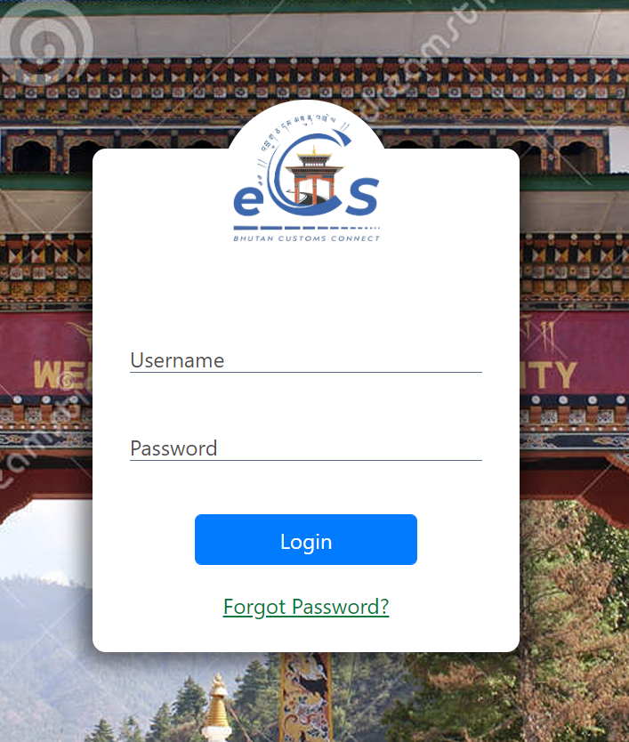
Fig.4. eCMS Login Page
- Enter the USERNAME and the NEW PASSWORD in the fields provided and Click “LOGIN” button.

Click>> LOGIN

- Upon successful login the Electronic Customs Management System Home Page will be displayed as shown below.
Dashboard Page

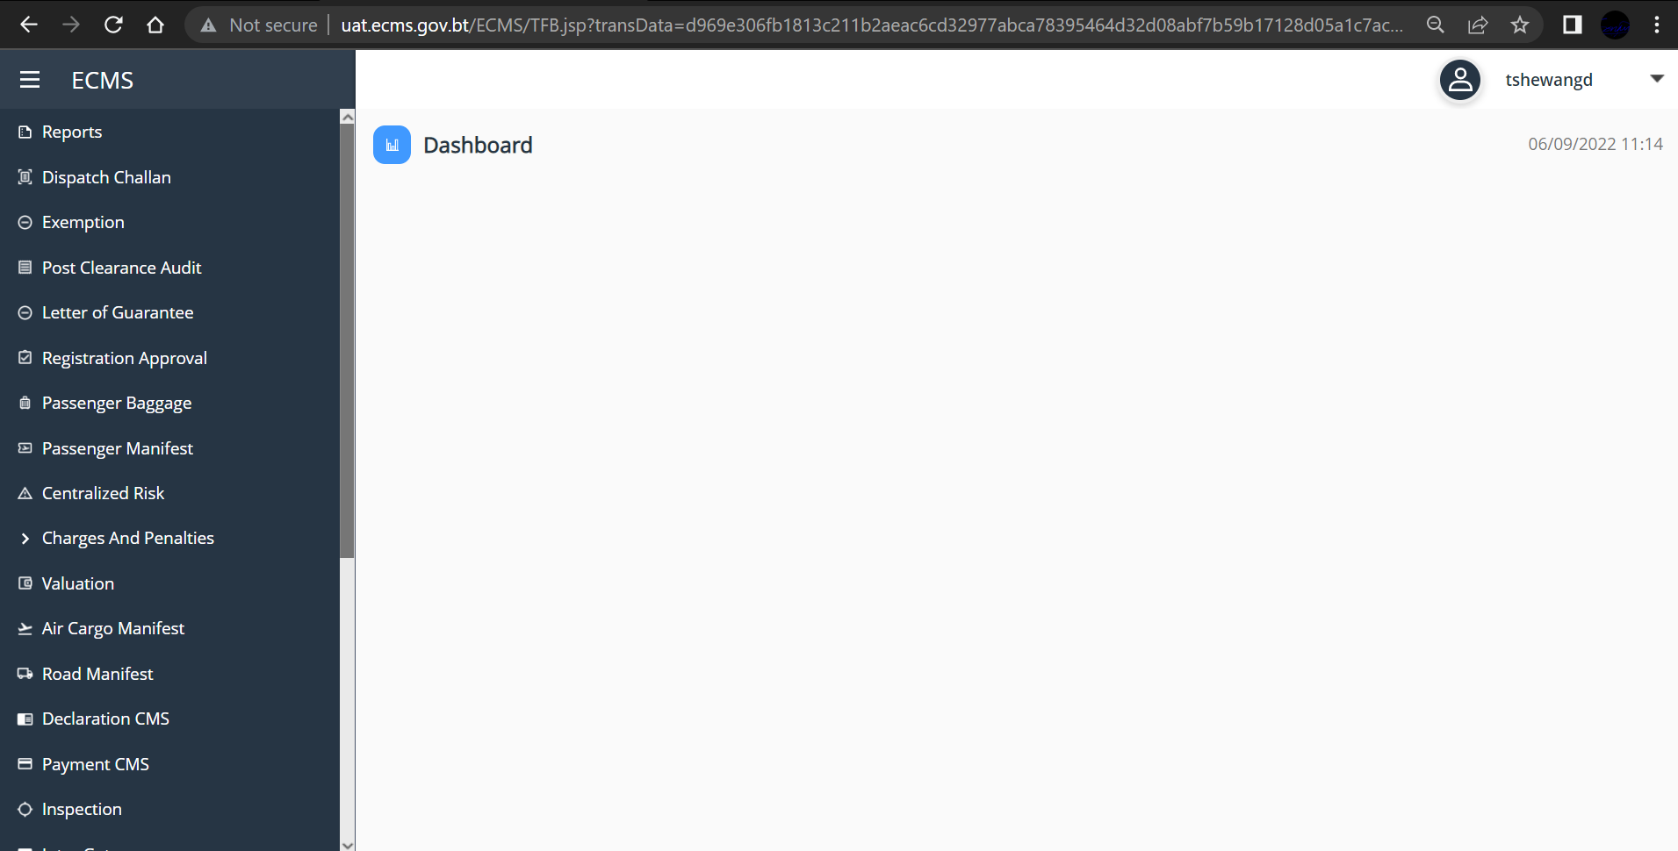
Fig.5. eCMS Dashboard (CFA)

Chapter 3- Approve International Transit Declaration.

Declaration Approval
- Go to Declaration menu and click on “Approve Declaration”. Subsequent Screen is displayed with the list of Declaration in the dashboard. Pending Declaration list are listed under “PENDING ACCEPTANCE DECLARATION”
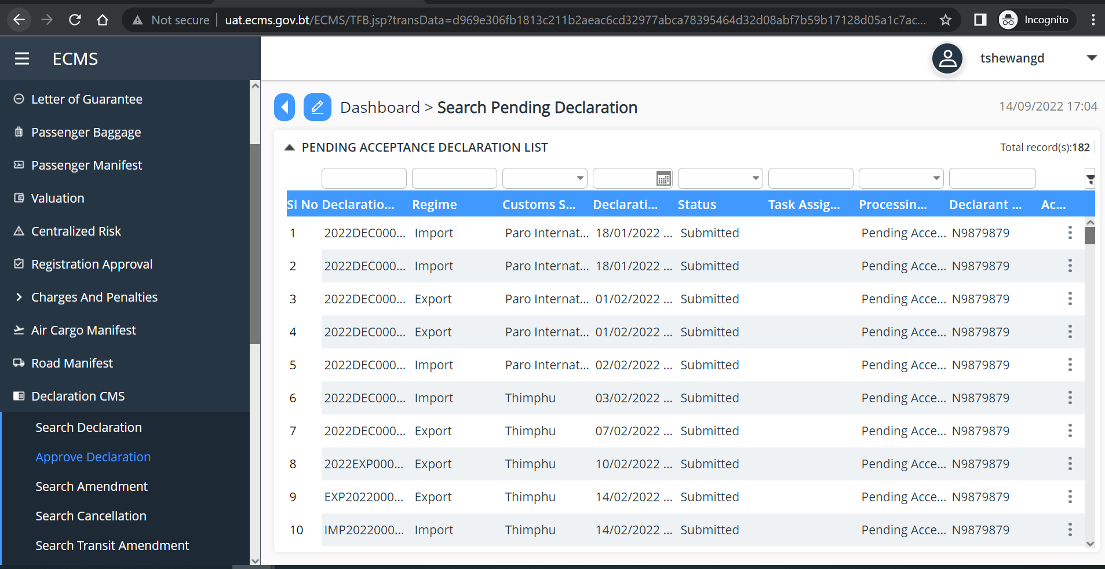
Fig.6. Approve Declaration Dashboard
@ | - You can track/search the Declaration with Declaration number/Regime/Customs Station/Date of Application/Status/Task assigned to/Processing Status/Declarant name/Action.
- Click on the Declaration to view details. The details can be view as below.

- General Information
Click to view the details
r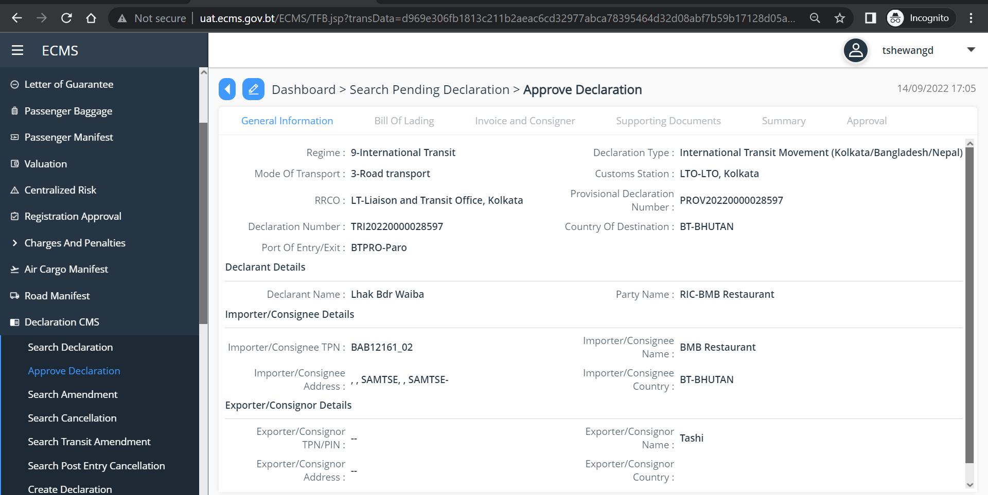
Fig.7. General Information
- Click>> Bill of lading,
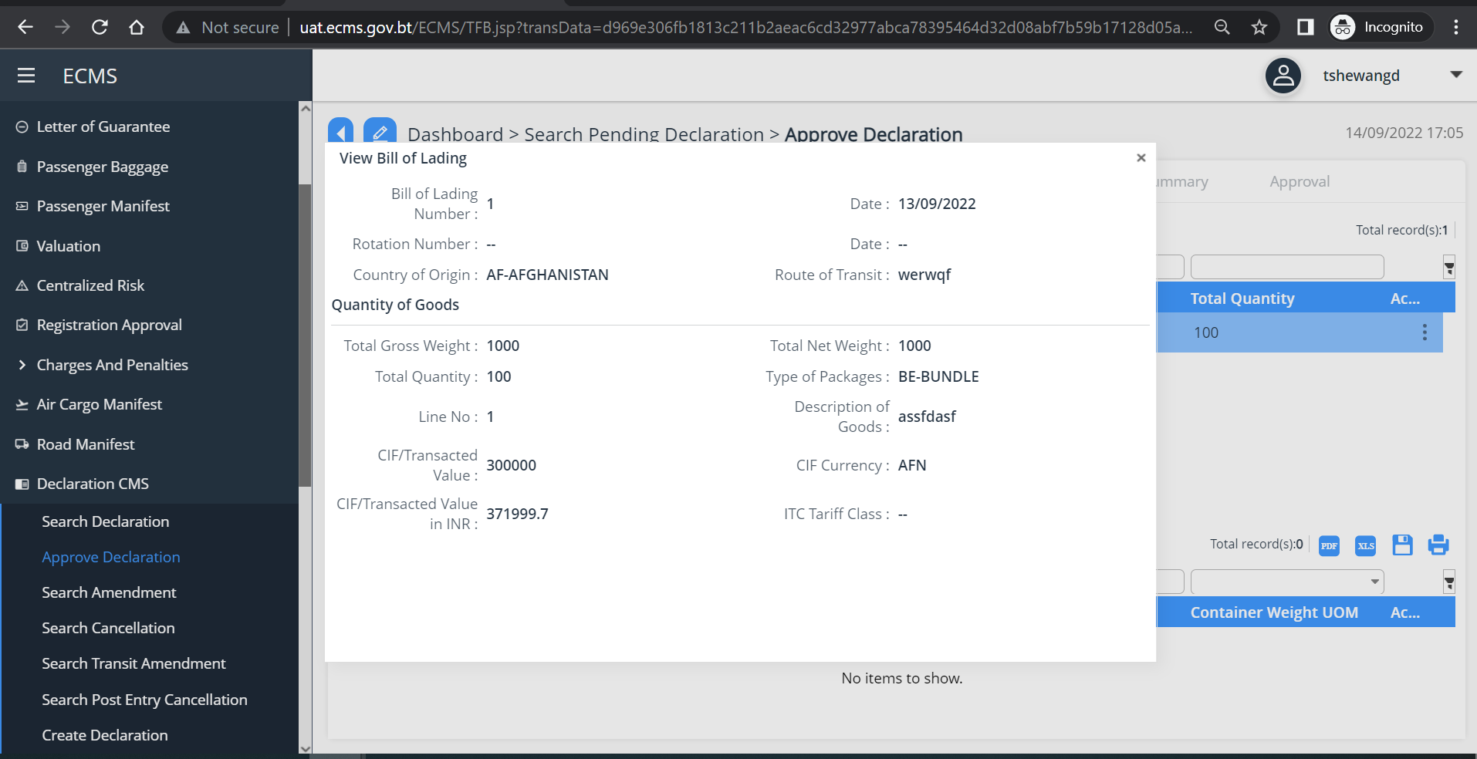
Fig.8. Bill of lading

- Invoice and Consignor
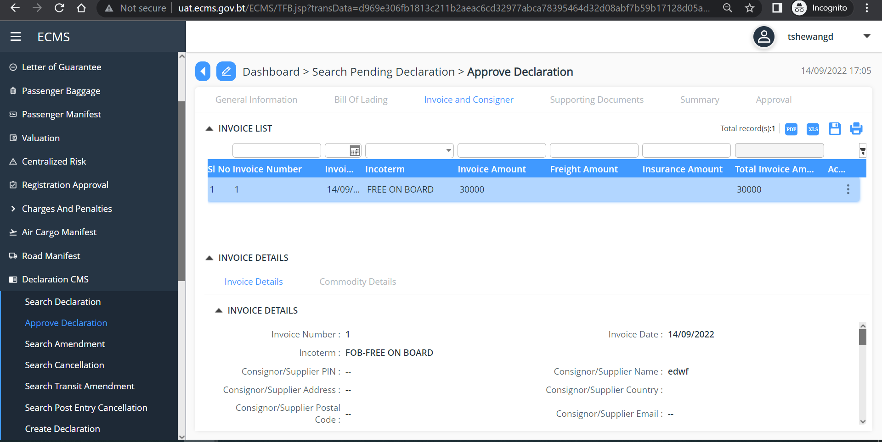
- Click>> Supporting Document
- Click on the three dots available at the right end of the supporting document to view the details.
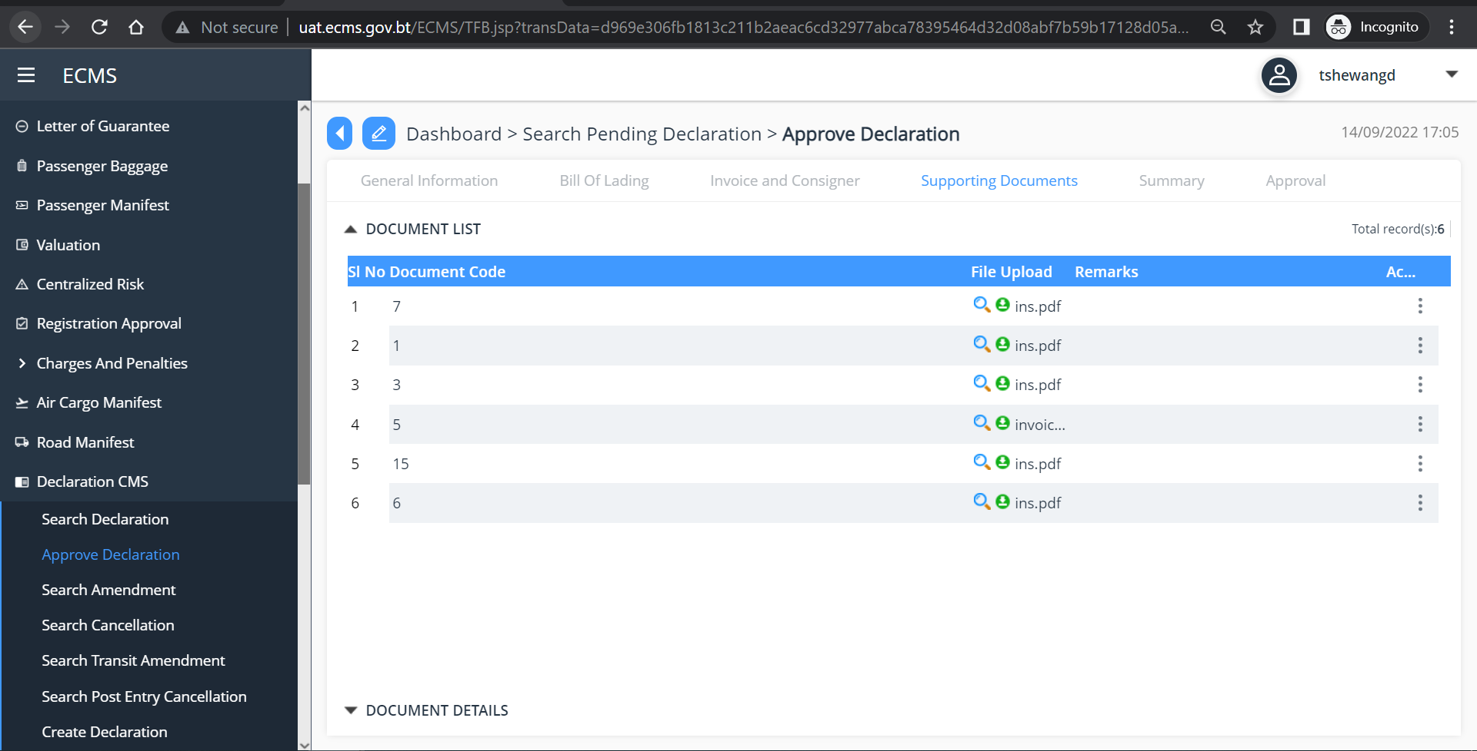
Fig.9.View supporting Document

- Click>> Approval
Table item in Dropdown list consist of;

Field name | Drop down list | Description
*Status | Approved | Mandatory
 | Rejected
 | Rejected for Amendement
Remarks |  | Non-Mandatory

- From the dropdown list in the *Status Field” select your decision as “Approved”/” Rejected”/” Rejected for Amendment”.
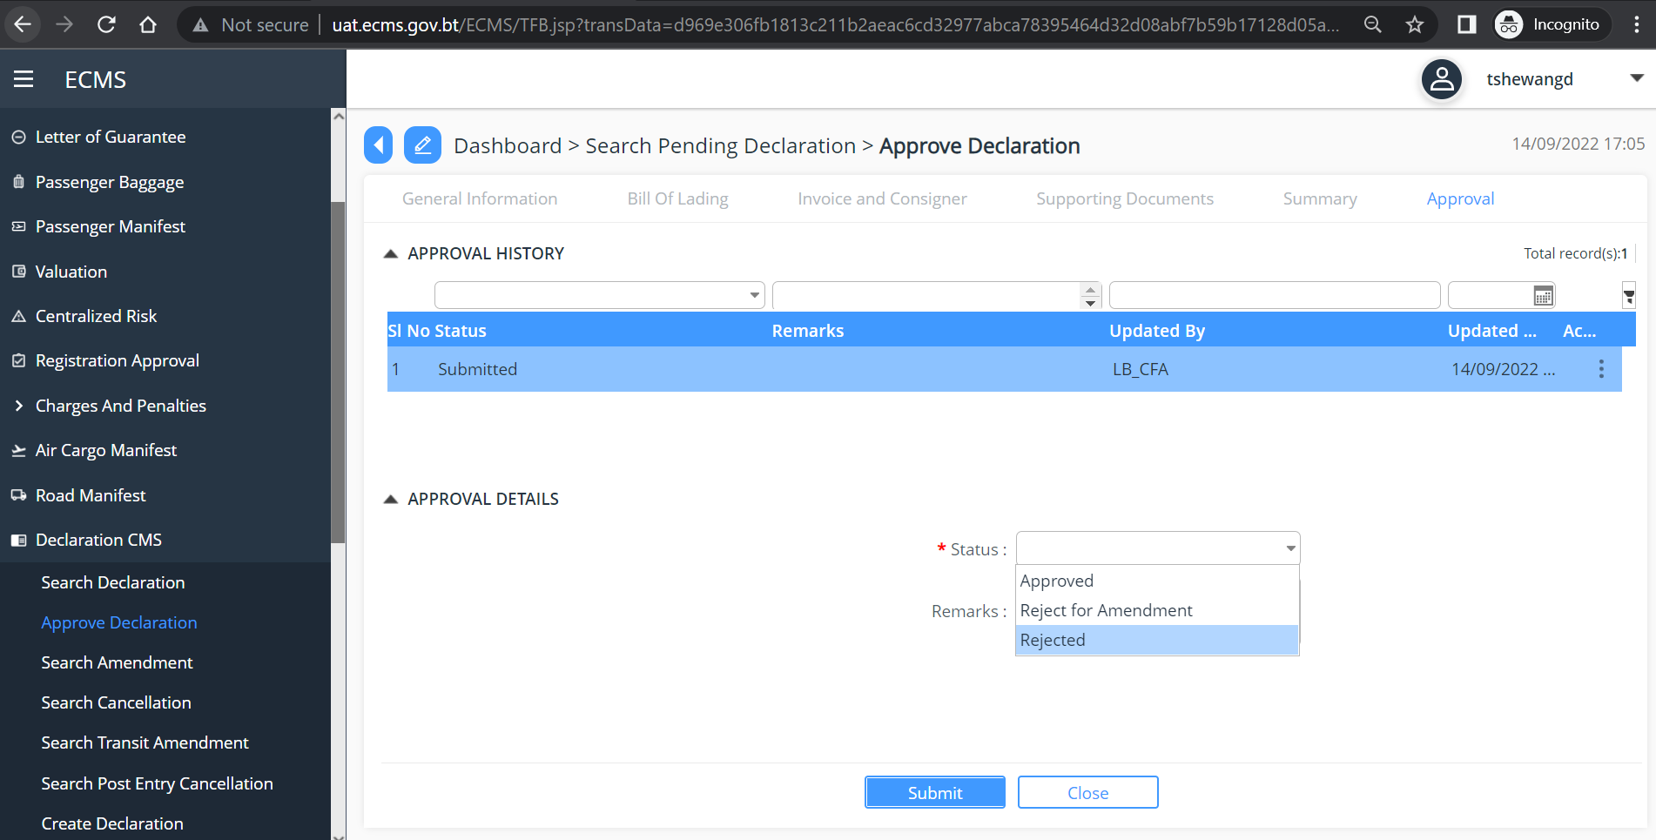
Fig.10. Approve Road Manifest

- Click >> “Submit”

Approve Dispatch Challen

@ | After the International Transit Declaration is Approved by the Customs, Letter of Guarantee (LOG) is created by the system. This LOG is used by the FE to Create the Dispatch Challan. Customs need to approve the Dispatch Challan, >Complete Release Order, >Release Cargo, >Gate Out Dispatch Challan and >Get Out Dispatch Challan. As shown here.
- To Approve Dispatch Challan, click on the Dispatch Challan in the Menu, and Click on Approve Dispatch Challan.

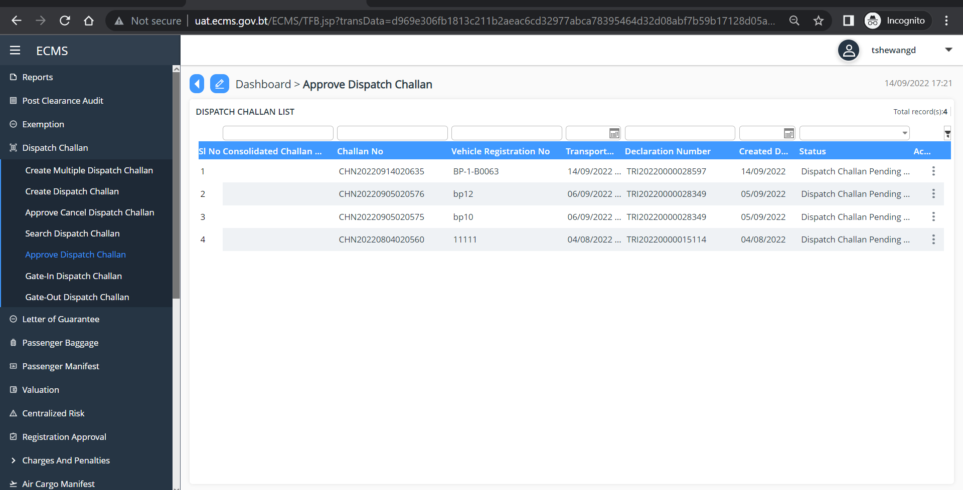
Fig.11. Approve Dispatch Challan

- Click on the Dispatch Challen list to view the details. Subsequent Screen is Shown
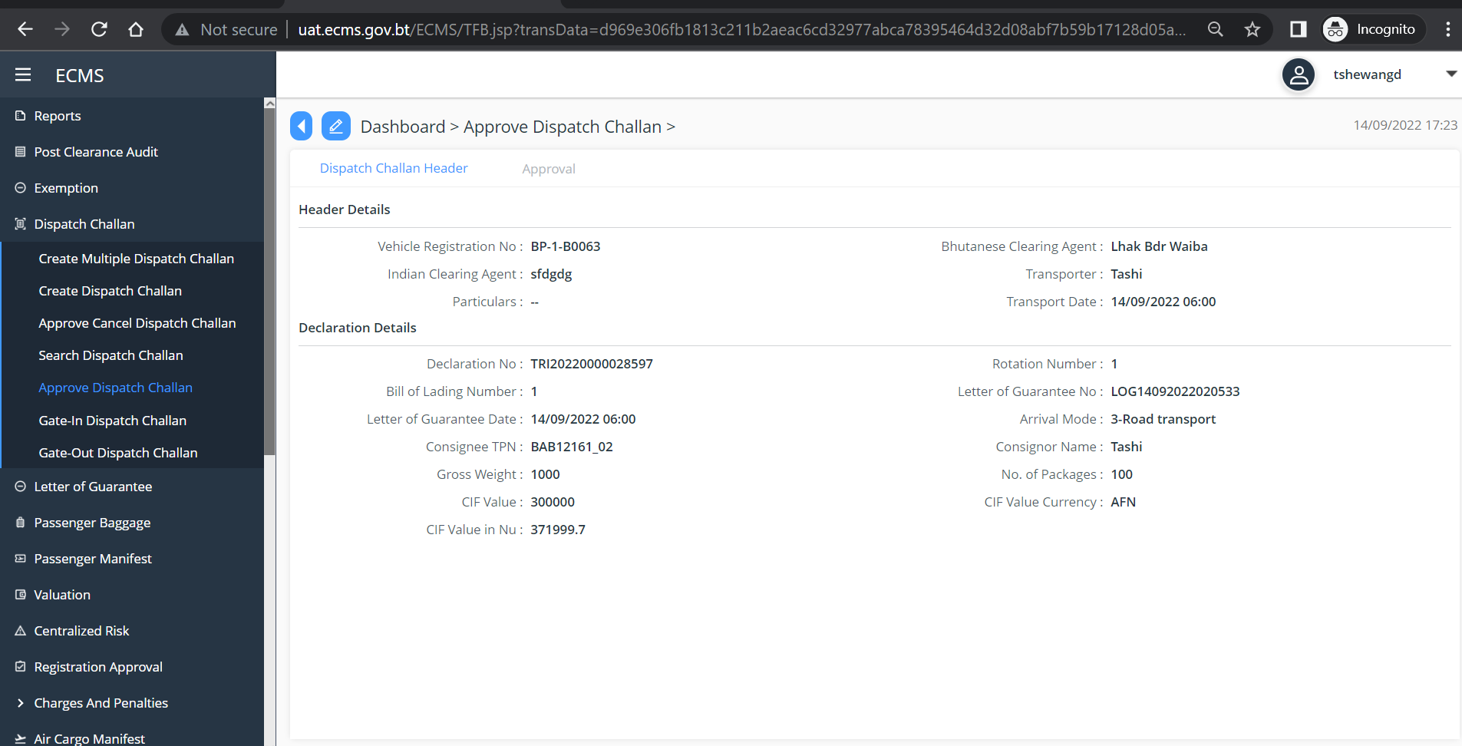
Fig.12. Dispatch Challan Details
- Under Approval, in the *”Status” field, Select the decission as shown in the screen below.
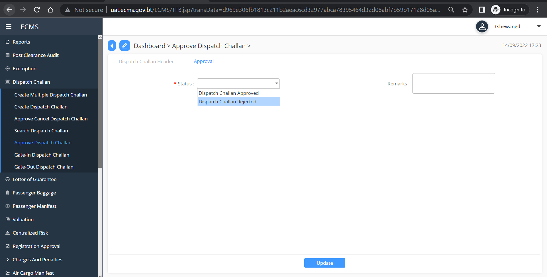
Fig. 13. Approval of Dispatch Challan.

- Click “Update”.

After the Approval of Dispatch Challan, the next Process is Realease Order.

Release Order
- Go to Release in the Menu and click on “Release Order”, Subsequent screen is displayed with pending release order list.

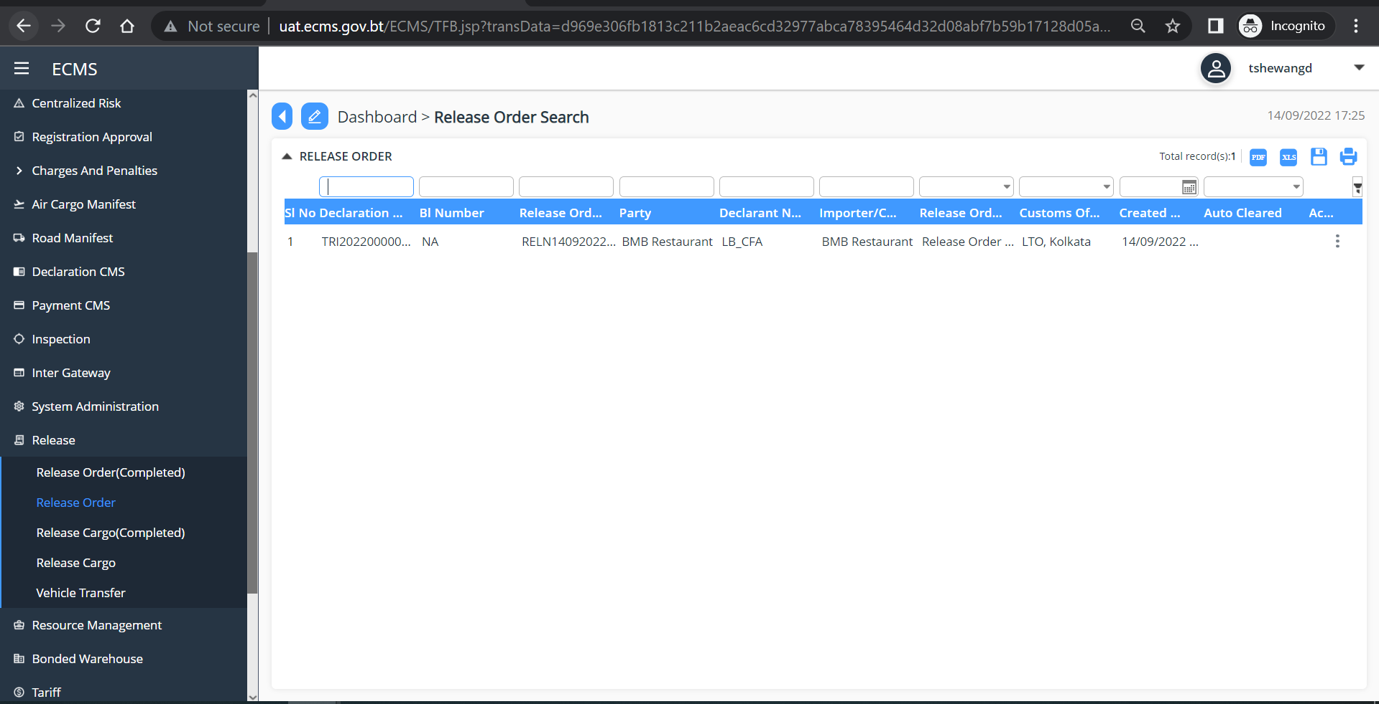

Fig. 14. Pending Release Order list

- Click on the list OR it can be view by clicking on the View button available under the three dots on extreme right of each list. Subsequent screen is displayed.
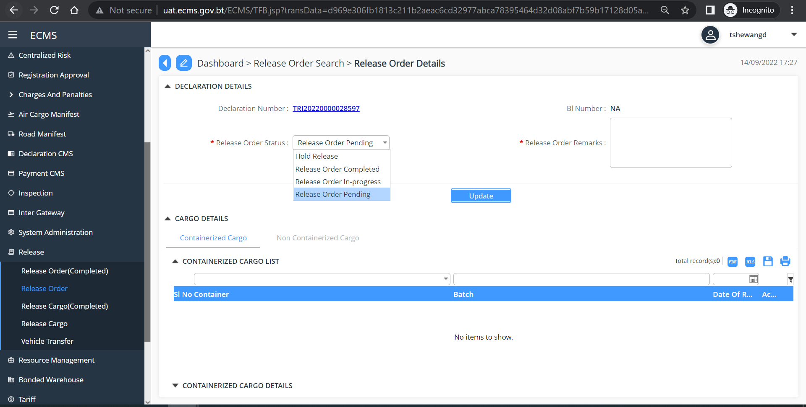
Fig. 15. View and Approve
- Update the release Order Status
- Click “Update”

Release Cargo
- Go to Release in the Menu and click on “Release Cargo”, Subsequent screen is displayed with pending Release Cargo list.

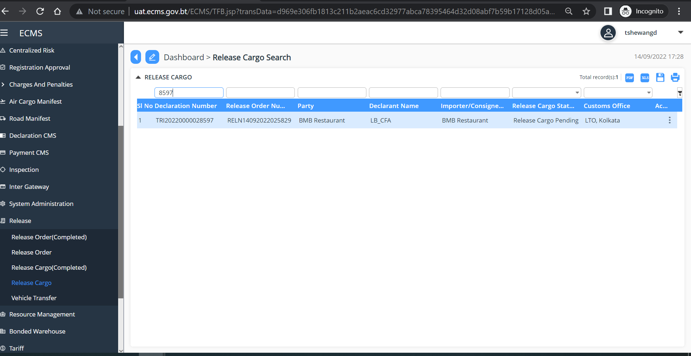

- Click on the list OR it can be view by clicking on the View button available under the three dots on extreme right of each list.
- If your Cargo is Non-Containerized, Click on “Non-Containerized Cargo” Subsequent screen is displayed.
- Fill in all mandatory details
- Select and update the Status from “Release Cargo Status” drop down list.
- Click Update.

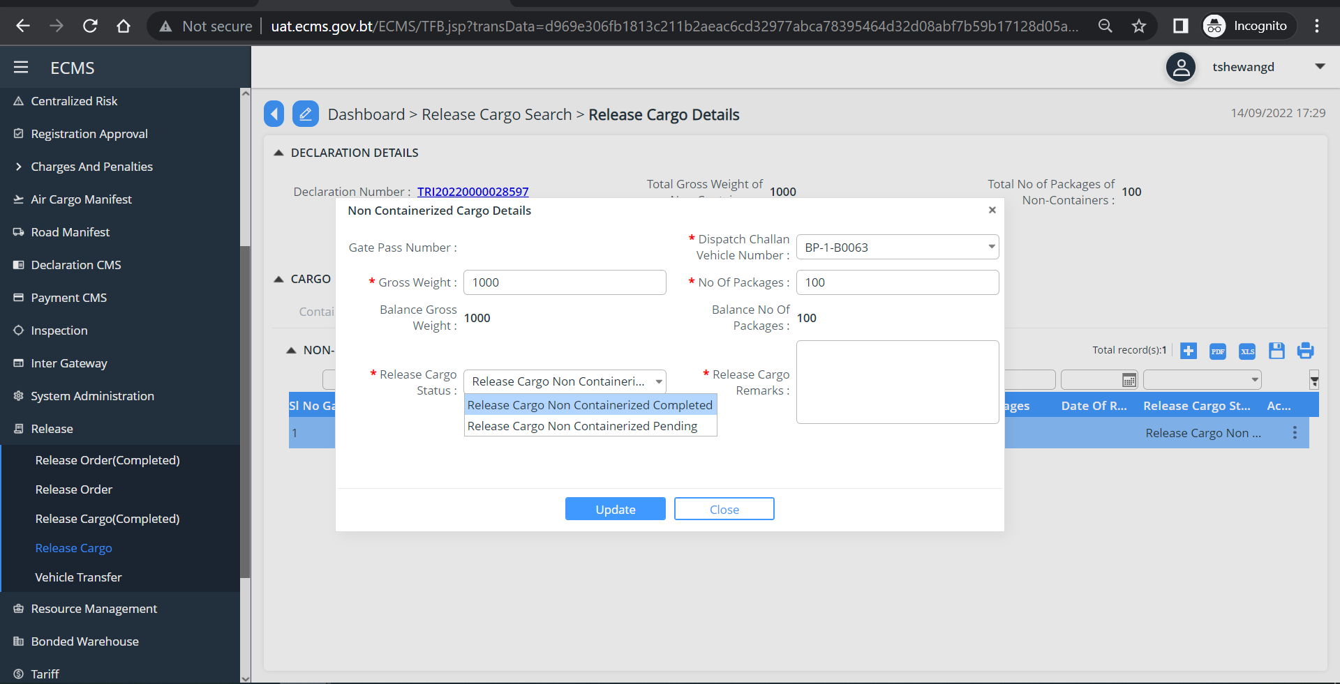

- Under “Release Cargo Completion” select decision from the “ Release Cargo status” dropdown list as shown below.
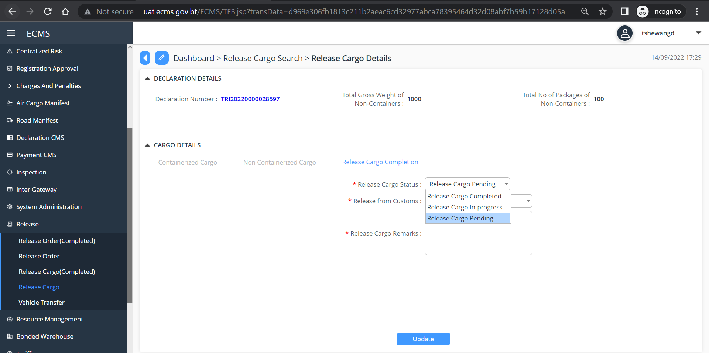

- Under “Release from Customs” select “YES” to release from custom.
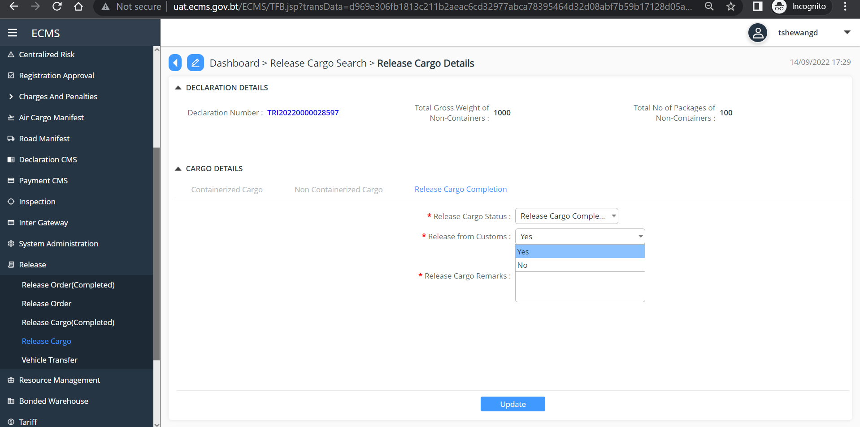

- Click “Update”

Get Out Dispatch Challan
- To get out the dispatch challan, go to dispatch challan in the menu, and select “Get Out Dispatch Challan”

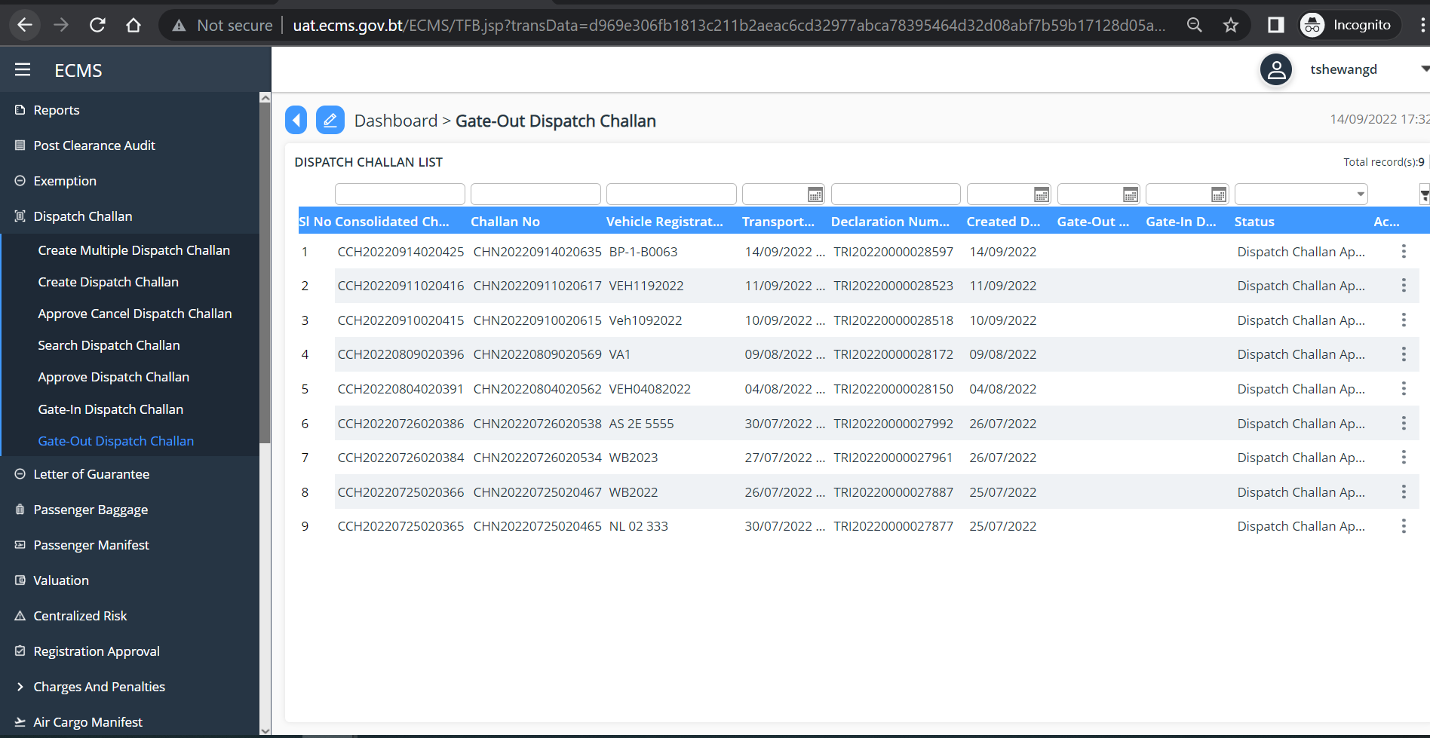

- Click on the list to view OR click on three dots available on the extreme right of each list and select view. Subsequent Screen is displayed.

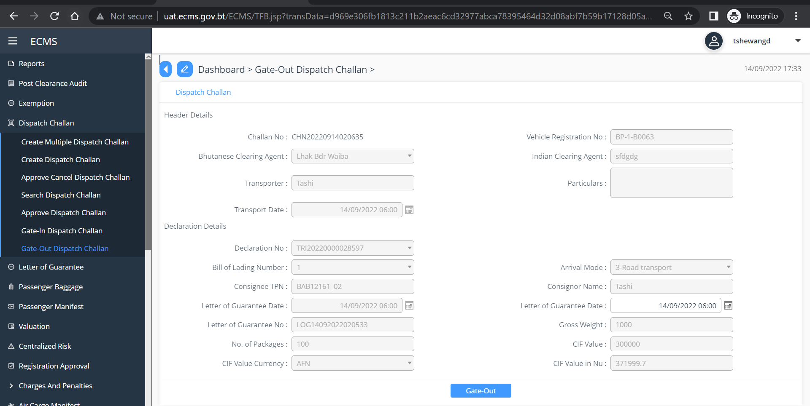

- Click “Gate-Out”

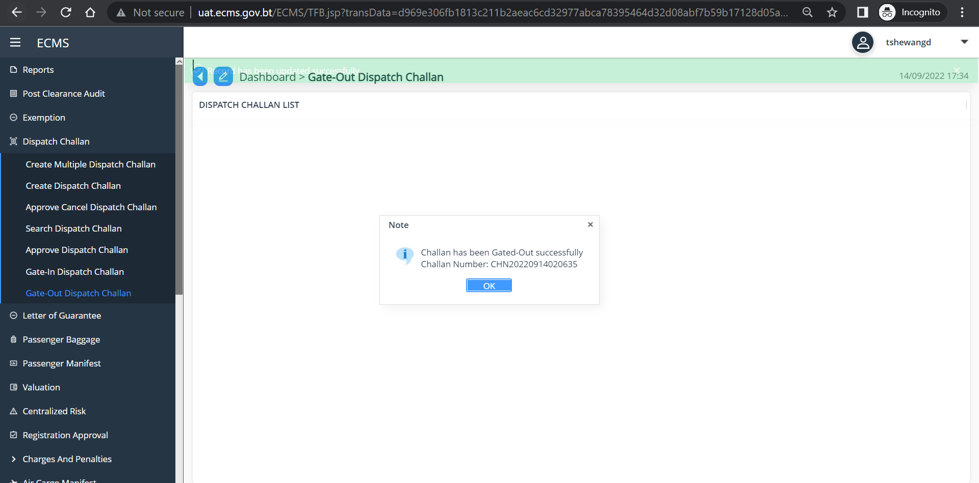

Get In Dispatch Challan
- To get out the dispatch challan, go to Dispatch Challan in the menu, and select “Get In Dispatch Challan”

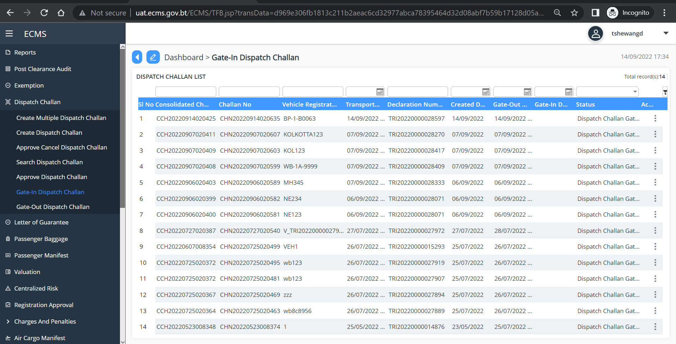

- Click on the list to view OR click on three dots available on the extreme right of each list and select view. Subsequent Screen is displayed.

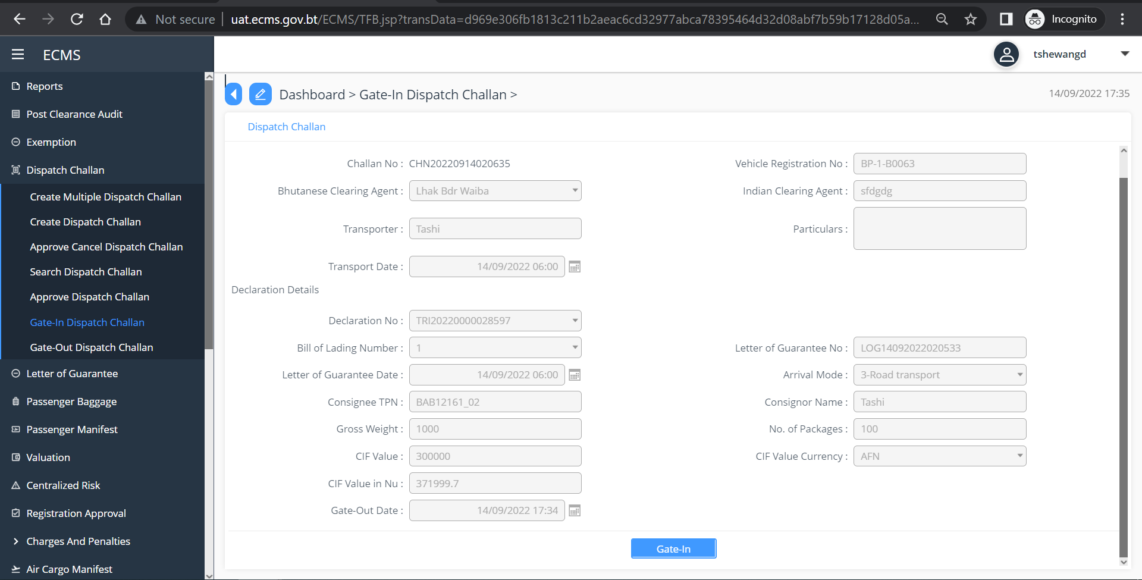

- Click “Gate-In”

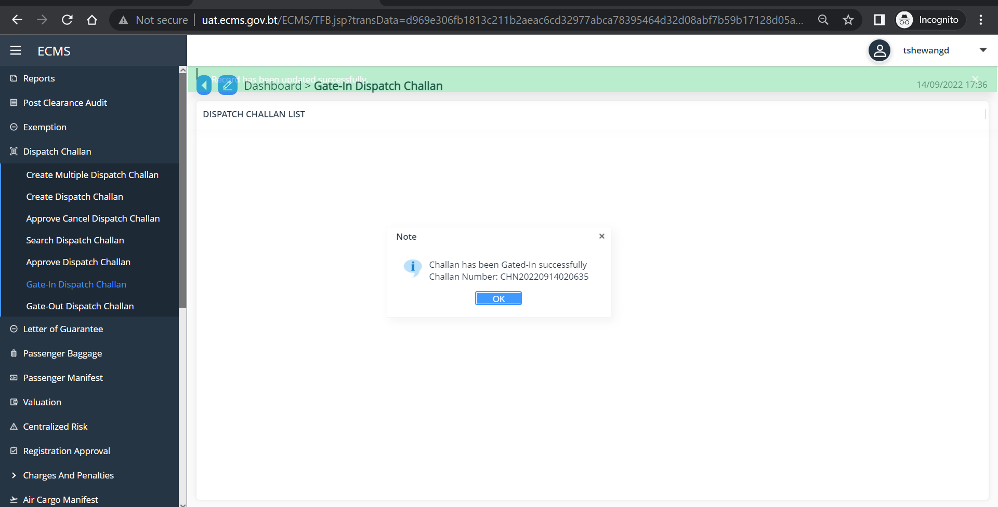

After Gate in, FE will process Import Declaration for direct entry for home use.

Customs will approve the Import Declaration.

After Approval of Declaration: Customs will need to clear all the following activities in the eCMS system.
- Payment
- Valuation
- Risk
- Release Order
- Release Cargo

Payment
- Go to Payment CMS in the menu and Select “Payment Voucher” subsequent screen is displayed

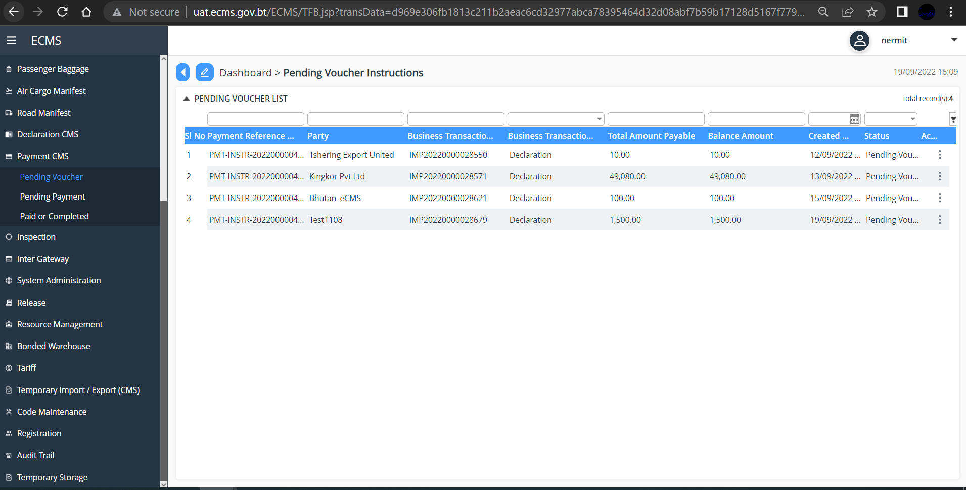

- Select the list and click to view the details as below, enter the Voucher number and click “submit”

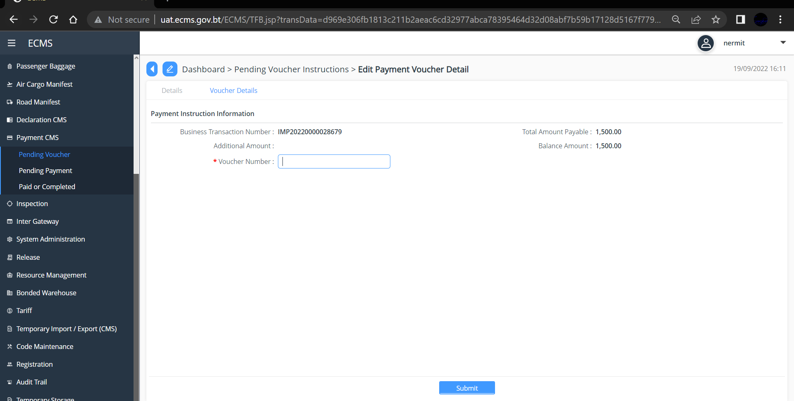

Pending Payment
- Go to Payment CMS in the menu and Select “Payment Voucher” subsequent screen is displayed

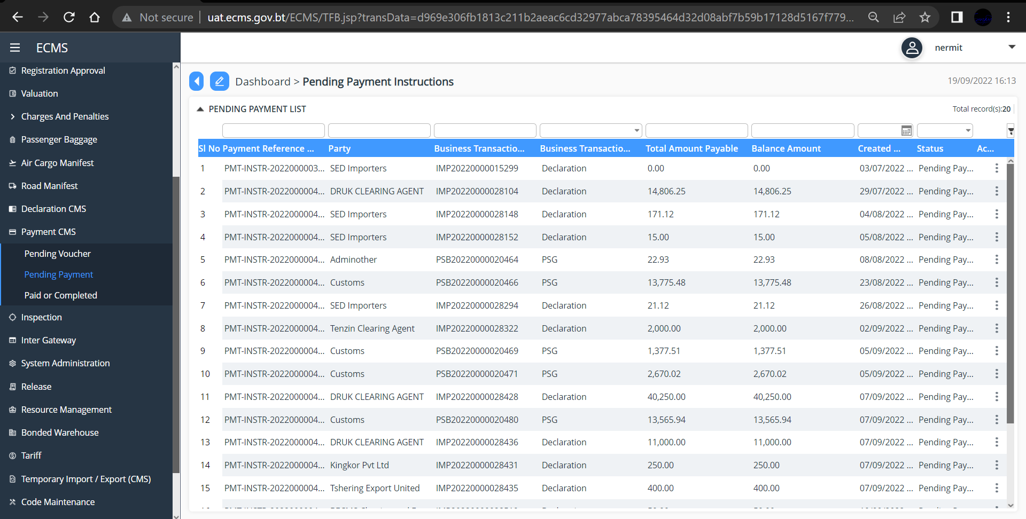

- Select the list and click to view the details as below, and under Payment section as shown below, update the Receipt Number and Location. (select location name from the dropdown list)

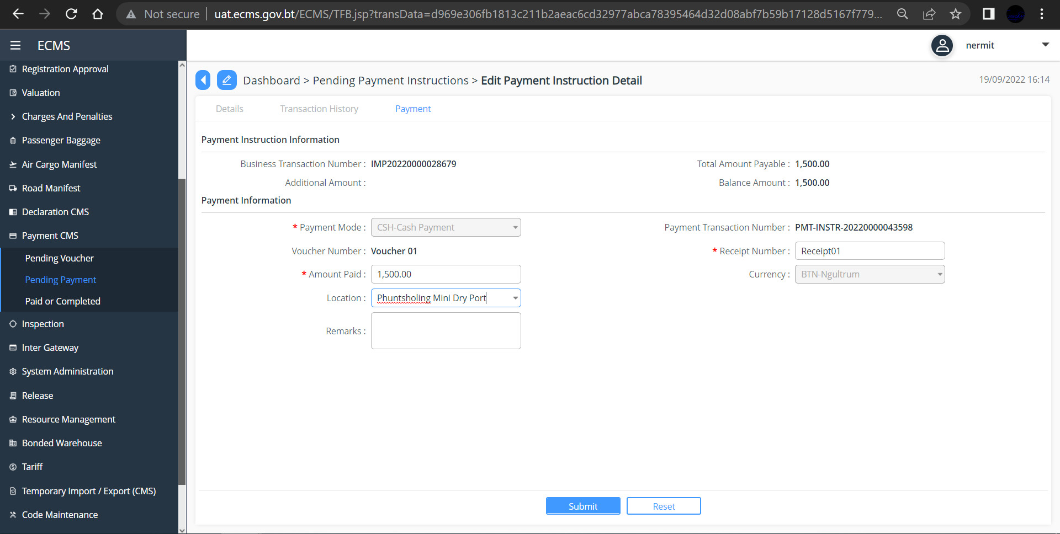

- Click “Submit” subsequent screen with successful payment transition will pop up.
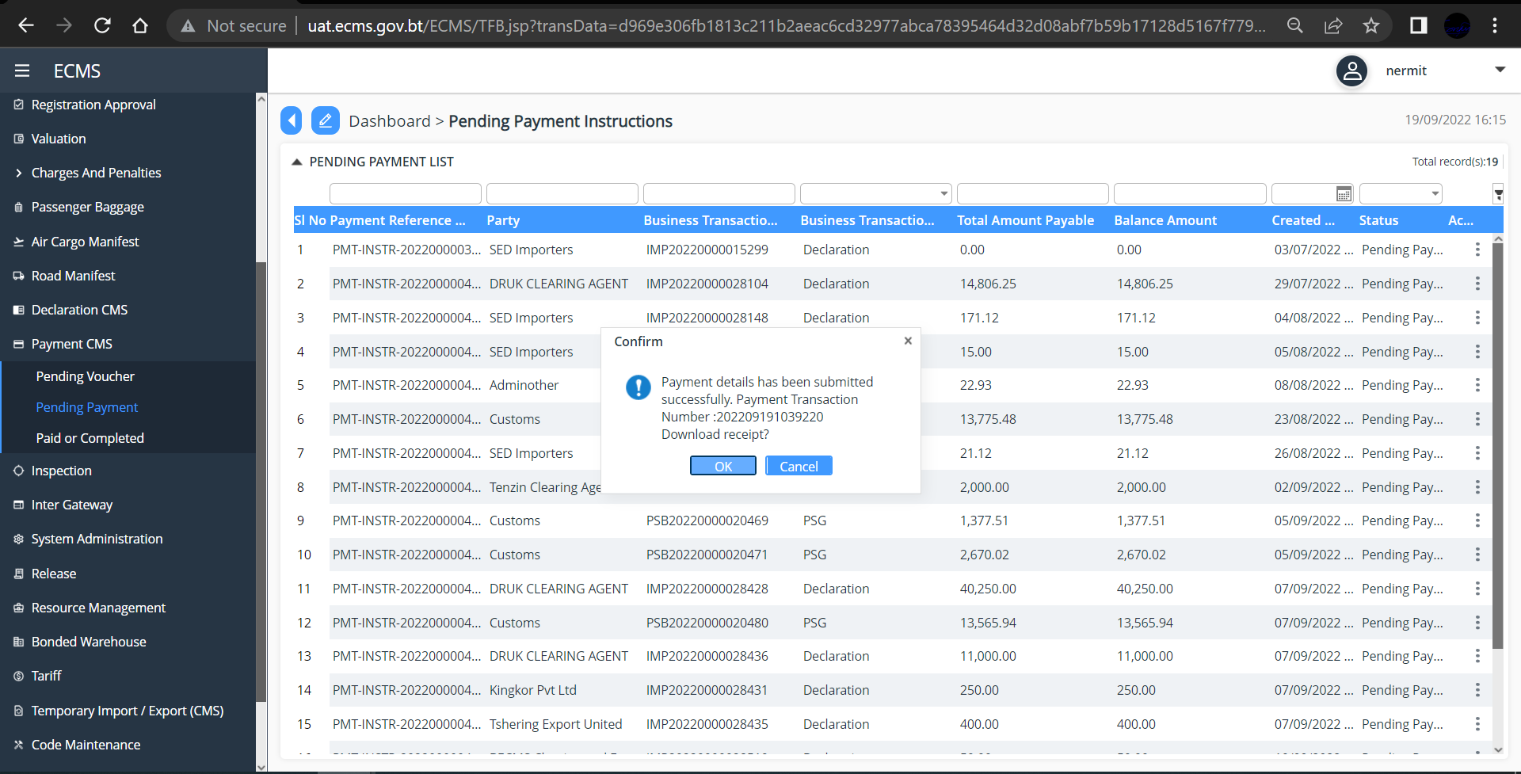

- Click Ok” payment receipt will be downloaded as viewed below.
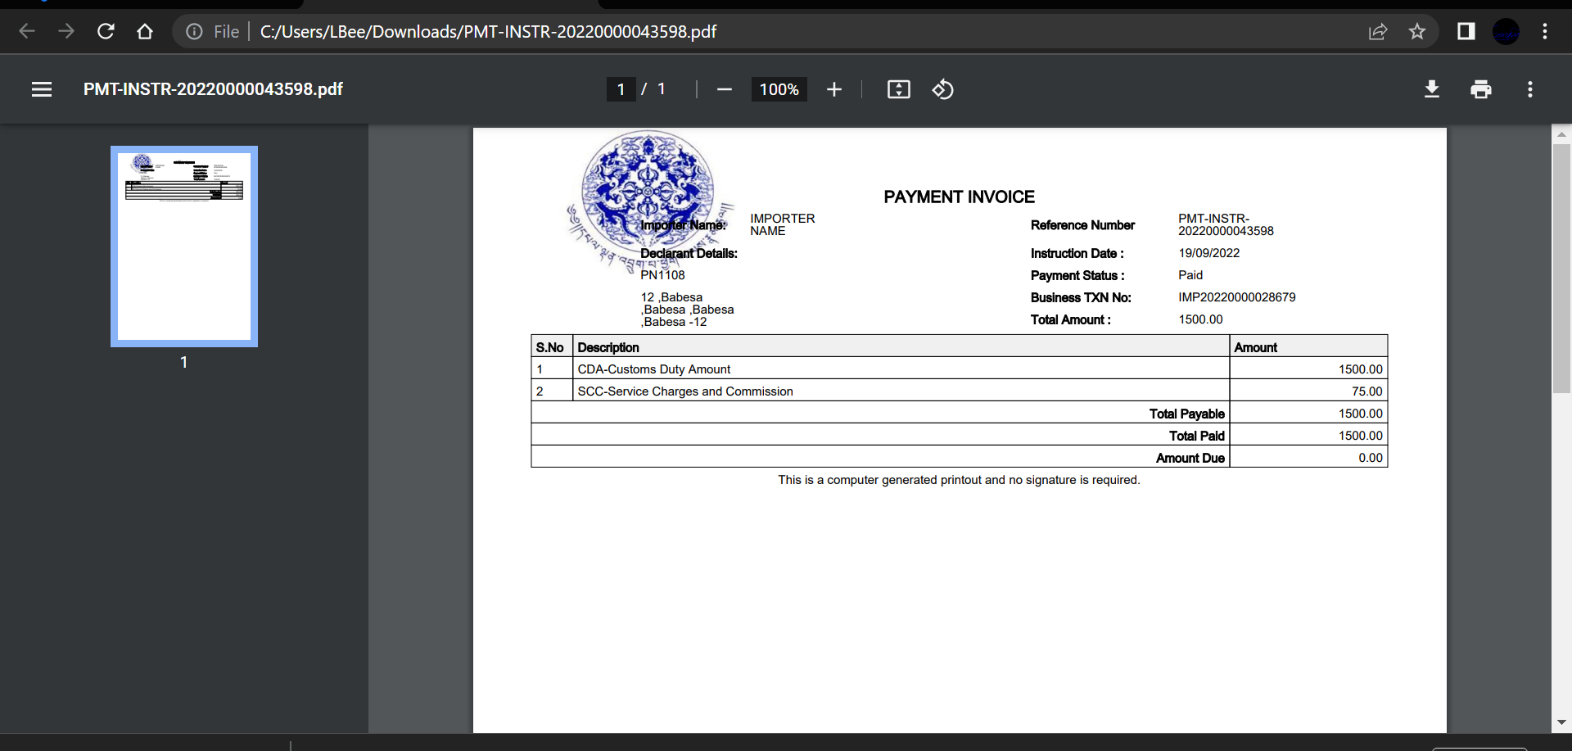

Valuation
- Go to valuation in the menu and select “Pending Valuation List” subsequent screen with pending list will be displayed.

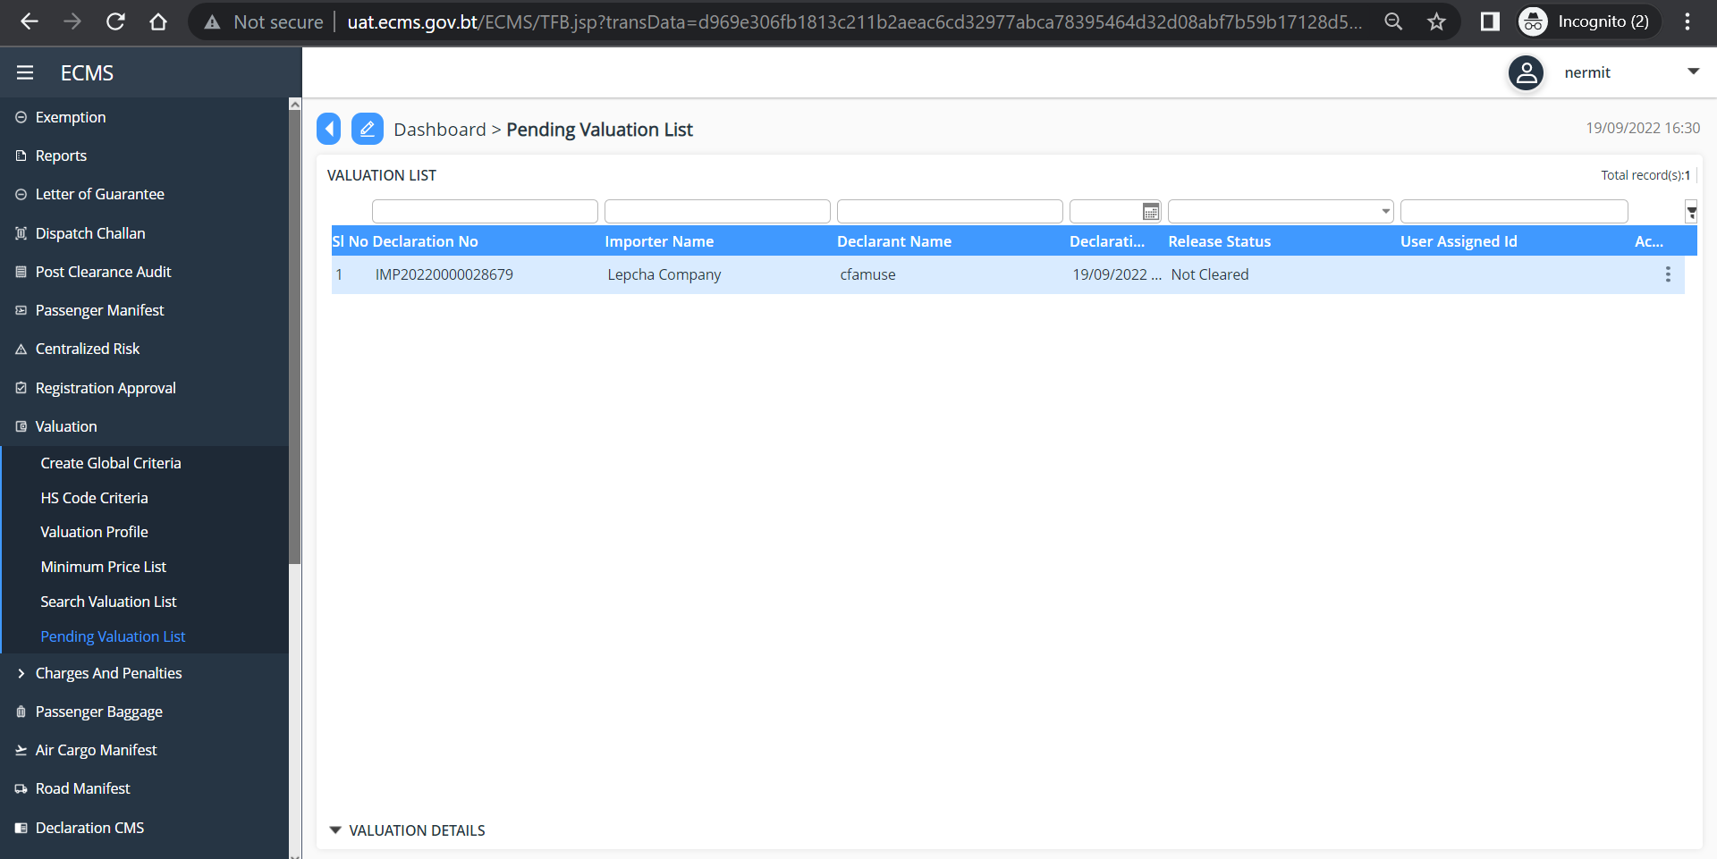

- Click on the valuation result list and fill in all the mandatory fields. Under “Release Status” filed select the status “Cleared” and click “Update” button.

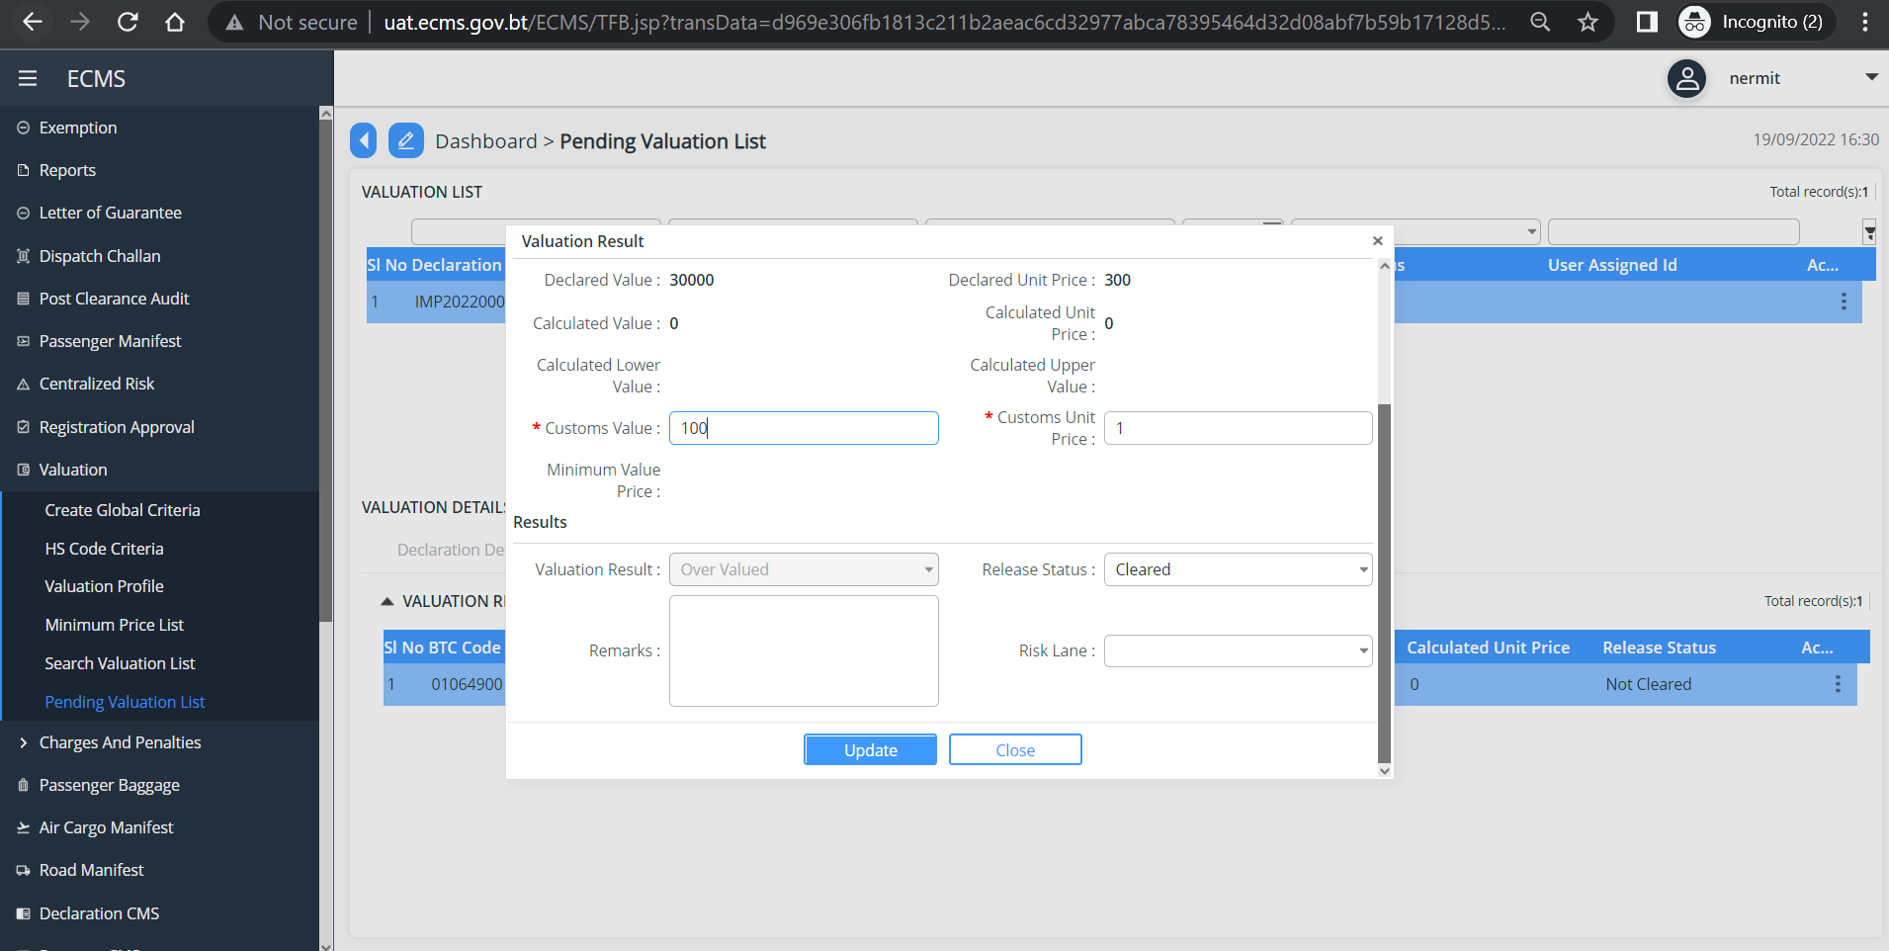

Centralized Risk
- Go to centralized risk in the menu and select “Pending Risk Assessment” subsequent screen is displayed.

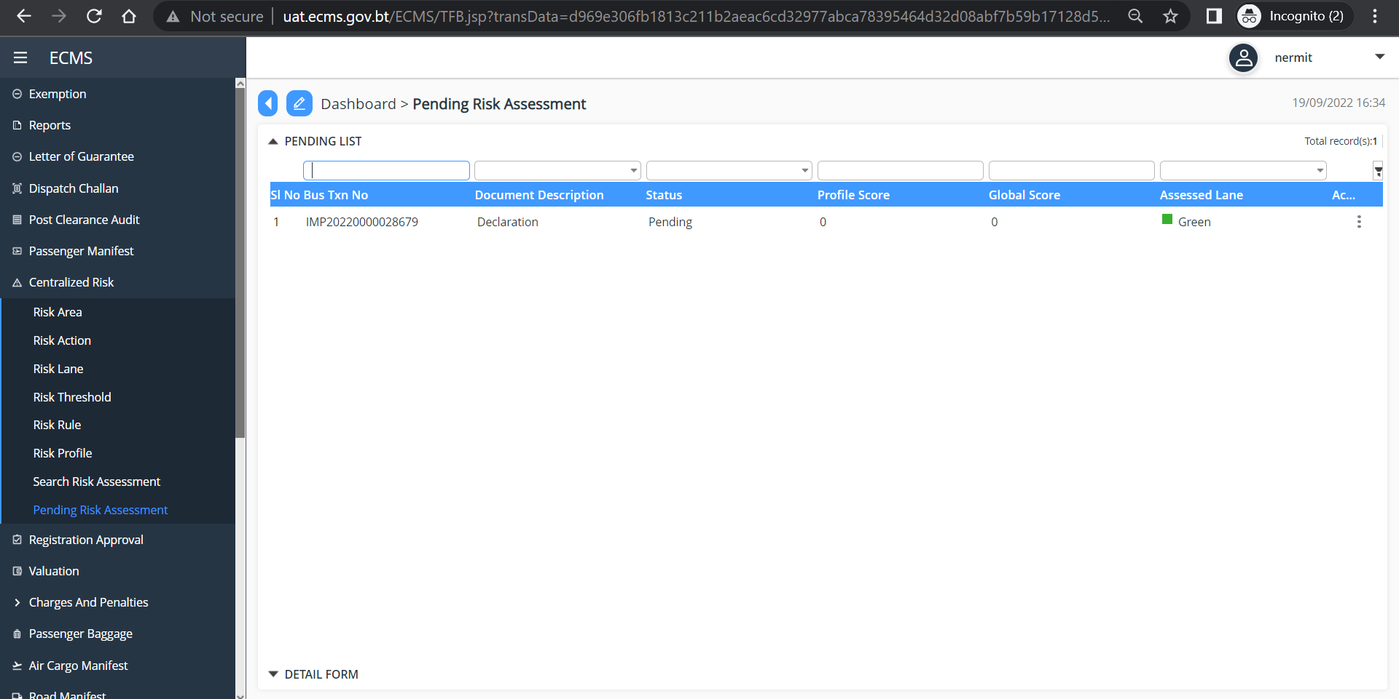

- Click on the list to view OR you can view by clicking on the three dots available on the extreme right of each list and click view.
- Under Header, update your remarks.
- Click “update” button.
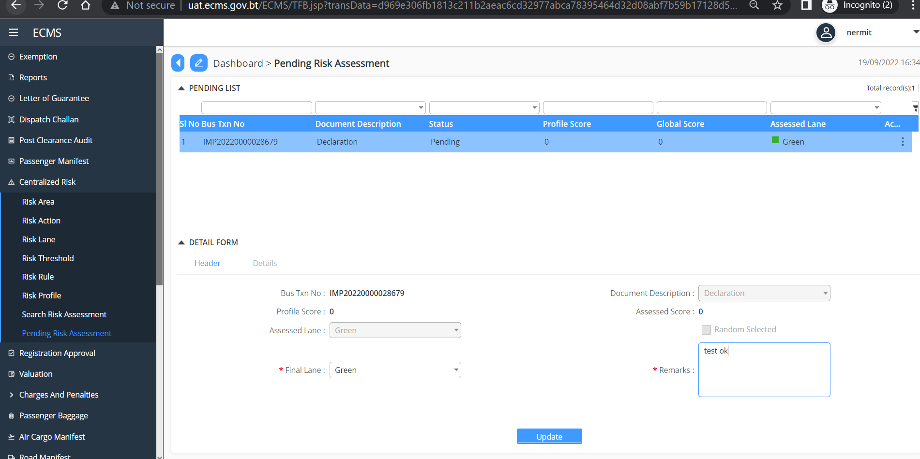

Release Order
- Go to Release in the menu, and Select “Release Order” subsequent screen with list of pending release order is listed

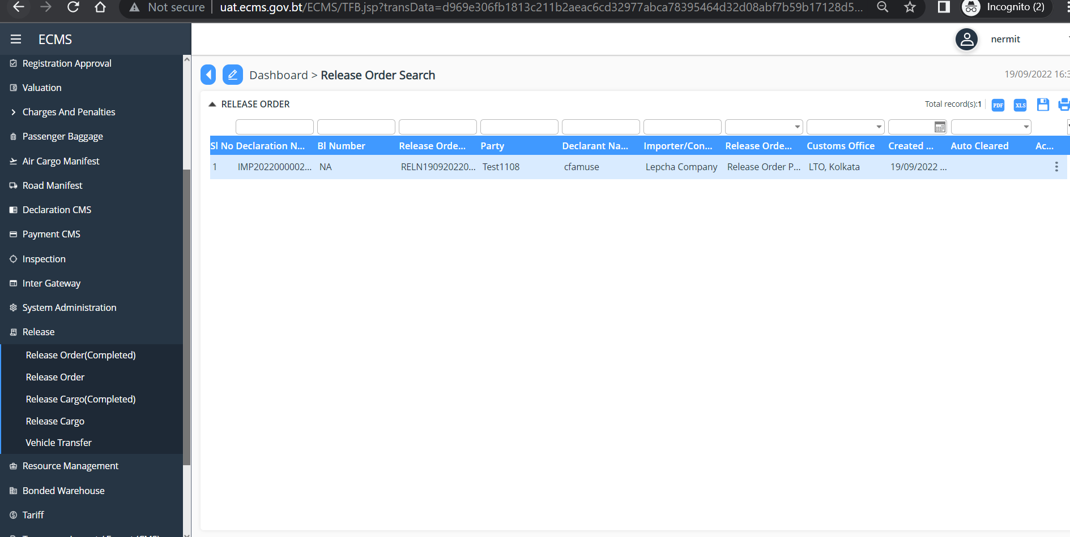

- Click on each list to view. Below screen is displayed
- In the “Release Order status” select “Release Order Completed” from the drop-down list as given below.
- Add Release Order Remarks
- Click the ‘Update” button
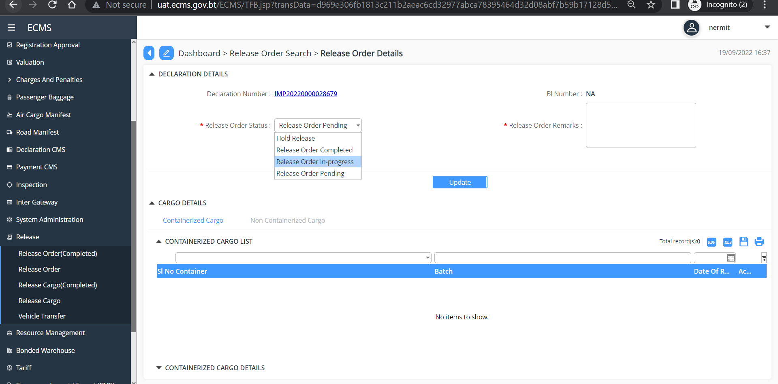

Release Cargo
- Go to Release in the menu, and Select “Release Cargo” subsequent screen with list of pending release cargo is listed

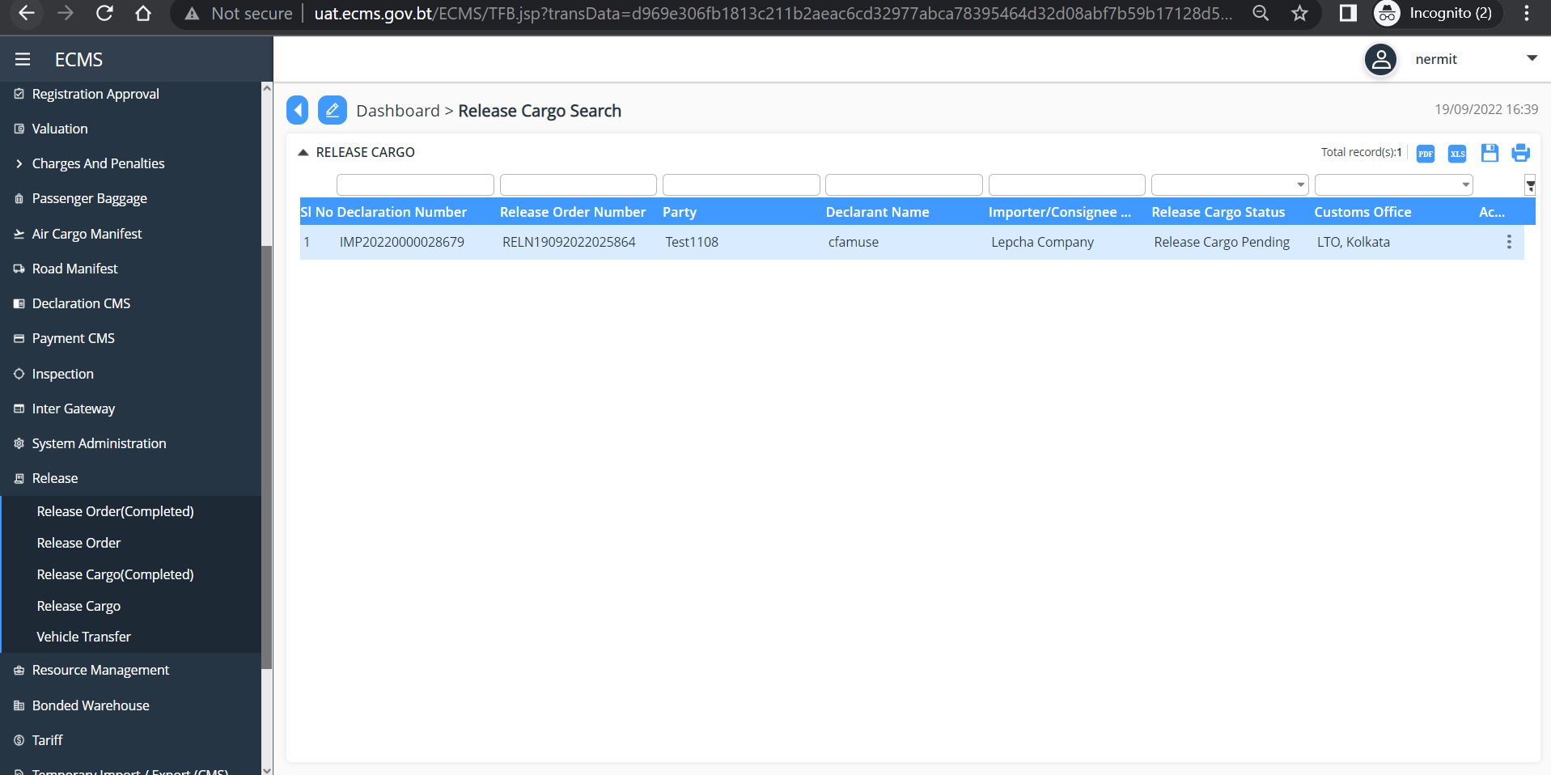

- Click on the given list to view. Under “Non-Containerized Cargo Details” Subsequent screen is displayed.
- Fill in all the mandatory fields
- In the “Release Cargo Status” field select the status as “Release Cargo, Non-Containerized Completed”
- Add the Remarks
- Click ‘Update” button
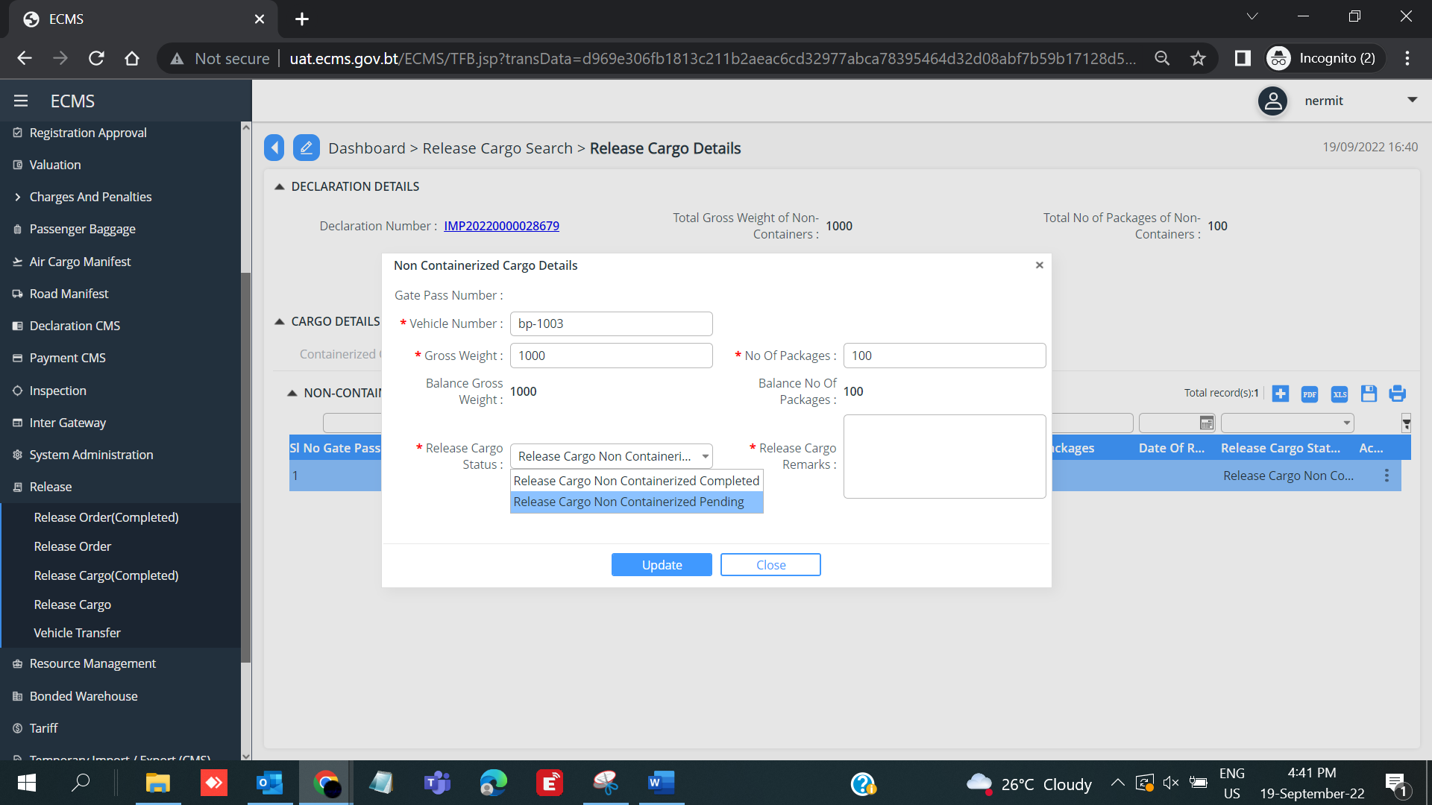

- Under ‘Release Cargo Completion” In the “Release Cargo Status” select the Status as Release Cargo Completed” from the dropdown list.
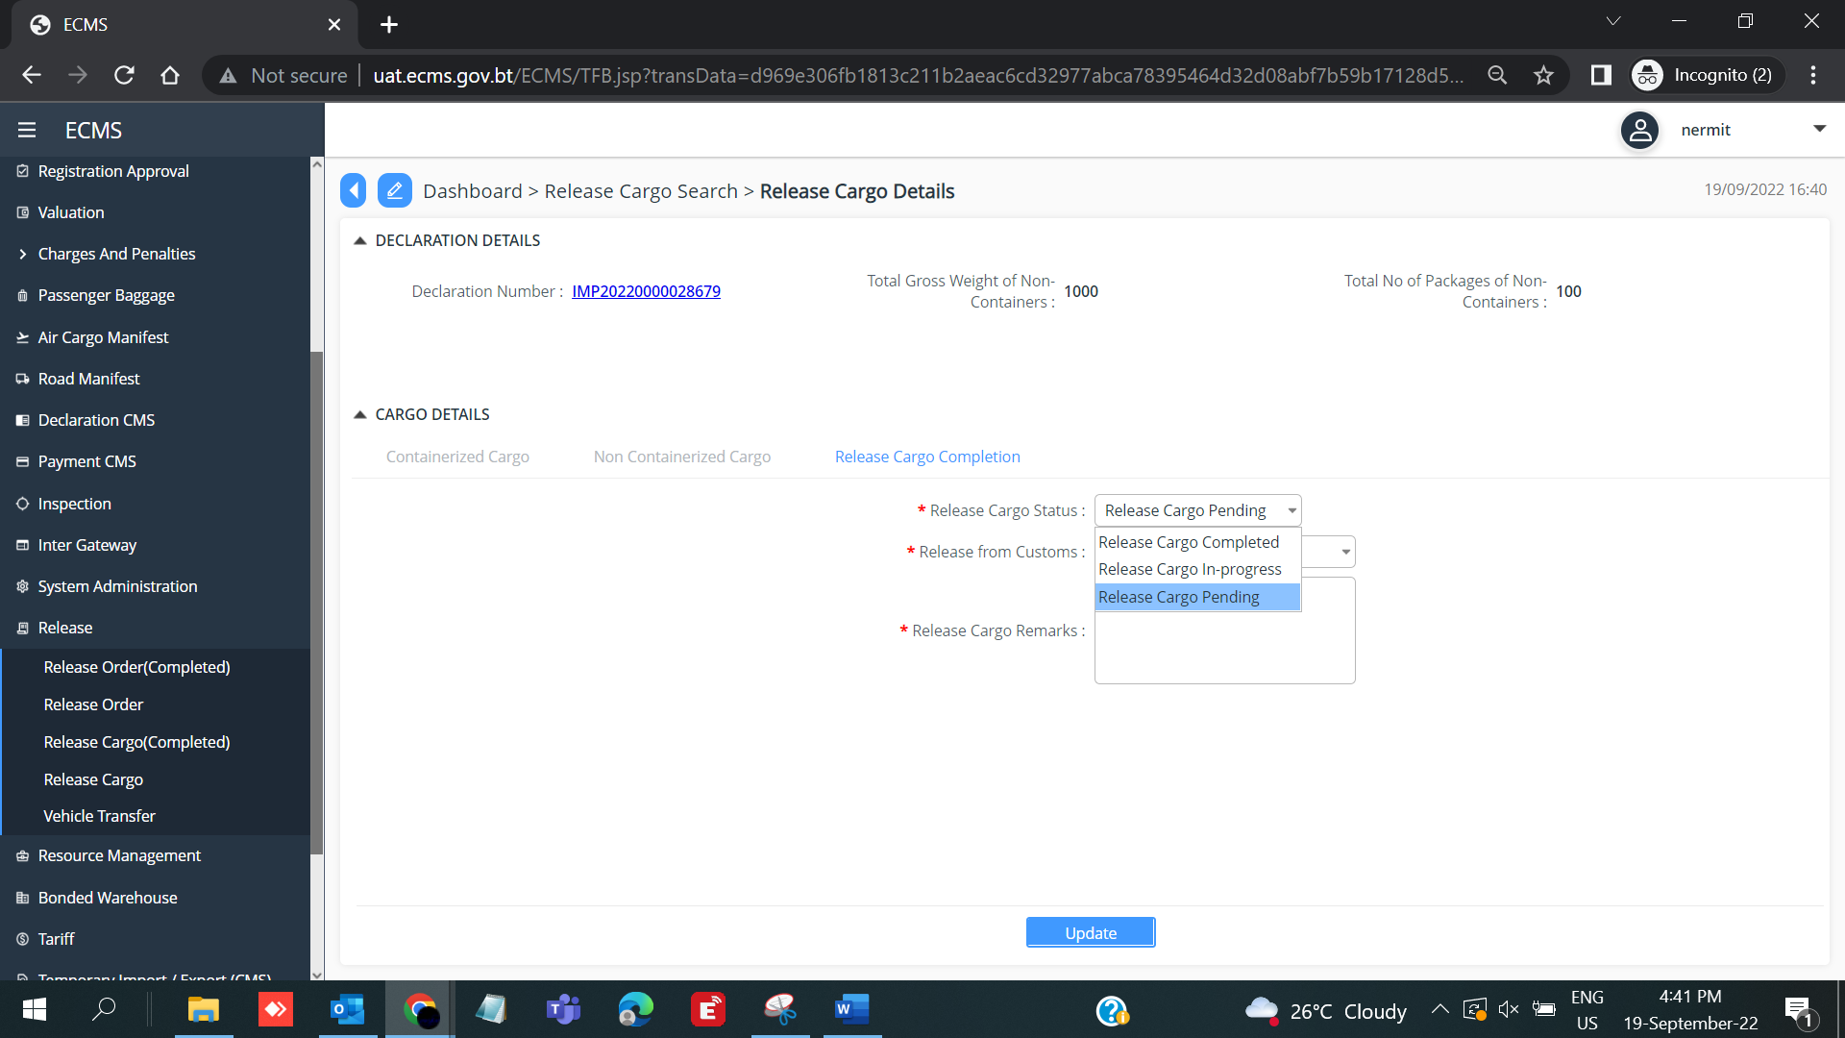

- In the “Release from Customs” field, select “YES” from the dropdown list.
- Add Release Cargo Remarks
- Click Update.
